AssetXD
Instructional Design Plan (IDP)

Instructional Design Plan

Contact:
People Development

Address:
2800 Speakman Drive
Mississauga, Ontario, Canada L5K 2R7
www.hatch.com

Table of Contents
1. Introduction 1-1
1.1 How to use this guide 1-1
1.2 Program objectives 1-1
1.3 Program guiding principles 1-1
2. Audience analysis 2-1
2.1 Target audience 2-1
3. Instructional design strategy 3-2
3.1 Design solution: Articulate Rise online courses 3-2
3.2 Preferred structure of online courses: 3-3
3.3 Level of interactivity 3-4
3.4 Writing guidelines 3-5
3.5 Common Hatch terms (previous term → to be used term) 3-5
3.6 Visual approach 3-6
4. Evaluation Strategy 4-8
4.1 Knowledge Checks 4-8
5. Additional LMS micro-learning requirements 5-9
5.1 Completion requirements and progression 5-9
6. Videos 6-10
6.1 Technical specifications 6-10
6.2 Demonstration/Simulations/Practices 6-10
6.3 Reporting requirements and Technical Specifications 6-11
7. Translation 7-11
7.1 General approach 7-11
8. Appendix 8-12
8.1 Knowledge check resources 8-12

Introduction

How to use this guide
The purpose of the instructional design plan (IDP) is for the project team to create a set of guidelines to be used in building the program, course, etc. The team should collaborate on the plan and share it with the chosen vendor/contractors. The vendor/contractor should review the document and have a collaborative conversation about it (adding, changing, and subtracting where needed) with the project team. In this way, the IDP can become a project asset and tool to be used and referred to throughout the entire design, development, implementation, and evaluation processes.

Program objectives
- Resource projects using AssetXD with competent staff.
- Build Hatch’s reputation as experts and trusted partners to our clients.
- Leave clients a lasting impression to continue winning work with each client in the future.

Program guiding principles
- Adopt a learner centric approach by giving learners only the information they need.
- Allow learners to practice the skills and knowledge being presented in a practical and realistic manner.

Audience analysis

Target audience

Primary audience
Audience | Learning required | Rationale
- Engineers  - Designers | - Basic topics  - Advanced Topics | This group will be working with AssetXD daily
- Project Managers (PM’s)  - Engagement Managers (EM’s) | - Overview  - Navigation  - Access  *Other Basic/Advanced topics are optional | This group needs to navigate AssetXD, find information within AssetXD, and manage issues.
- Project Information Managers (PIM’s),  - Project Automation Technologies (PAT’s)  - engineering design coordinators | - Basic topics  - Advanced topics  - Setup  - Train the Trainer | This is the group that needs to setup projects within AssetXD and will need to troubleshoot issues within it. This group will be the group called upon to be future trainers on the tool for Hatch.

Secondary audience
- Subject Matter Experts (SMEs) across other tools/products

Instructional design strategy

Design solution: Articulate Rise online courses
The purpose of online courses is to provide impactful foundational knowledge in a concise and easily digestible manner because AssetXD is a minimum digital standard and must be used on all Hatch engagements.
Those taking the online courses will have the ability to practice skills and concepts following the viewing of the online courses. Within the program and online courses, the learners will be able to select pathways/content that meet the needs of their individual roles.
It should also be noted that the AssetXD courses will contain a Virtual Instructor Led Training (VILT) session component to assist with transfer of more complex skills and activities and allow for feedback and practice beyond and in support of the foundational knowledge and skills to be taught in the online courses.
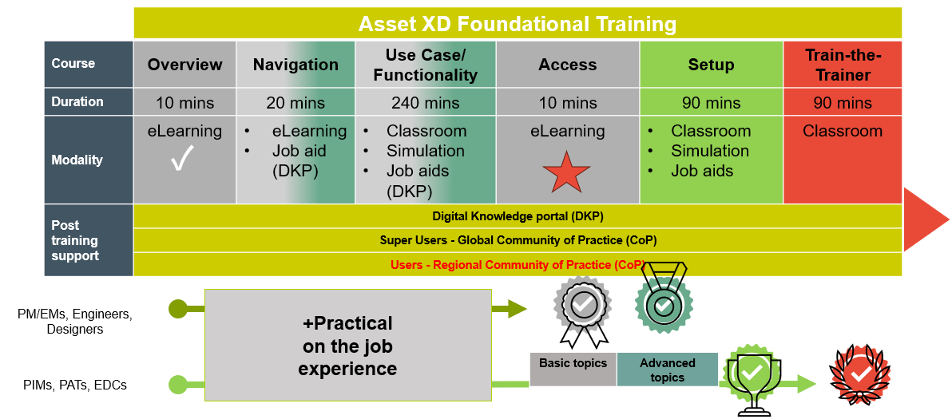

Guiding principles
- Keep it simple
  - Limit non-essential information (nuances, exceptions, flowery language).
  - Allow learners to select pathways/content specific to the expectations for their role.
  - Consider chunking information in smaller groups (you can remember about 3-4 things and then they disappear unless you repeat them).
  - Link to internal resources where applicable.
- Focus on being practical and relevant
  - Always complement new concepts/skills with examples and practice within a realistic and relevant Hatch context.
- Science and evidence-based
  - Our employees respect data and evidence.
- Follow the 4 M’s
  - Meaningful
    - For the learning process to occur effectively, content must be meaningful to the learners.
    - Consider reflection activities and scenario-based learning and knowledge checks that illustrate relatable and realistic situations.
  - Memorable
    - A mixture of activities, imagery, practice, and even surprise all culminates in a memorable learning experience that stays with the learner long after it is over.
    - Consider interesting and engage visuals that allow the learner to interact with content in a variety of ways.
  - Motivational
    - Consider dynamic openings, ways to capture and focus learner attention, and include engaging and applicable activities.
  - Measurable
    - Motivated learners, driven by memorable and meaningful experiences, will have a measurable impact on the business’ processes.
    - Consider that learning outcomes are able to be measured through knowledge checks, observations, etc.

Preferred structure of online courses
Online courses are to be standalone meaning they are to be easily digestible and useful. Online courses are meant to provide foundational knowledge and are to be easy to follow, structured to flow seamlessly from one section of the online course to the next section of the online course. Below is the preferred structure of an online course, although consultation with any vendor partners regarding their discretion around this format may be required.

Section | Items to include
Introduction | - Include information on how to navigate and interact with the course.  - Include an engaging sentence regarding the topic to engage our participants and help them quickly understand the relevance to their work at Hatch. Also include a few bullet points describing what specifically will be covered in the course (objective).  - List of learning outcomes of the online course.
Learning Content | - Define and explain concepts and skills in a way that is informative and resonates with the participant. This sections provides the “why” and details around the content being discussed.  - Foundational information can be covered via text and supported by screenshots, graphics etc.  - Where possible, link to live documents and SharePoint pages/libraries to ensure versions are able to be controlled and easily updated. This is especially important for items in multiple languages.  - Any documents linked for resource or reference should be in PDF format when possible (as log as a PDF format is logical for the item).
Demonstrations | - If applicable, the difficult or otherwise text-heavy concepts can be presented in the form of demonstration videos using uPerform and accessible through the course within Hatch Learning. See section below for requirements. Further detail can be found in the following: Demonstrations/Simulations/Practices  - Demonstrations can also be done via text/images (such as screenshots accompanied by text explanations).
Simulation activity or Knowledge Check | - Simulation activities will help learners to interface with the AssetXD tool and see how they can achieve the intended goals/outcomes using the tool in a safe environment. These can be created using uPerform and will be accessed within the course in Hatch Learning. Further detail can be found in the following: Simulation/Practice Inclusions  - Knowledge check activities should follow the guidelines linked in this section: Knowledge checks and should be directly linked to course learning objectives.  - Limit incorrect attempts in a knowledge check before revealing the answer and moving on to the next question.  - Suggest limit of 3 attempts on knowledge checks for purposes of awareness  - Suggest limit of 2 attempts on knowledge checks for purposes of practice/understanding at the end of a course  - Suggest limit of 1 attempt on knowledge checks for purposes of a formal/final assessment of skills/knowledge.  - Knowledge check and simulation activities can appear throughout the course, but there should be a more comprehensive or culminating activity for the course.
Key Takeaway and Conclusion | - This section should include a bulleted list of key takeaways directly tied to the course objectives.  - The conclusion should also include a message of congratulations and a certificate of completion with instructions for taking a screenshot of a this certificate for the participant to keep in their records.

Level of interactivity
Considering the target audience of this program, the online courses should contain a frequent mixture of both limited and complex interactions that will keep participants engaged.

Currently we are committed to utilizing levels 2 and 3 for eLearning content at Hatch.
Level | Description
1 | Online with passive interactions  (click-next to continue)
2 | Online with limited interactions 
3 | Online with complex interactions
4 | Online with advanced/real-time interactions  (e.g. game-based learning, gamification, social learning)

In general, participants are required to complete all page reading and interactions to progress to the next section (see Completion requirements and progression for details). Articulate Rise interactions include:

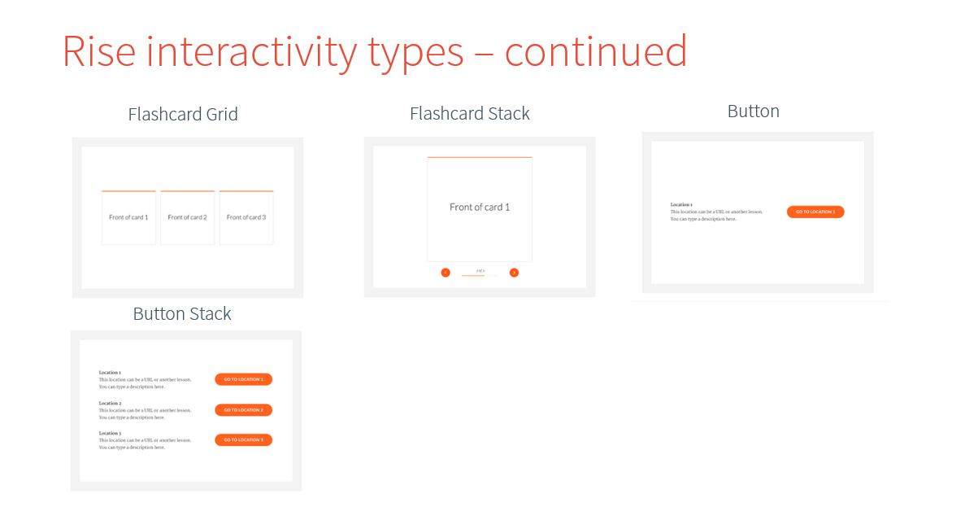
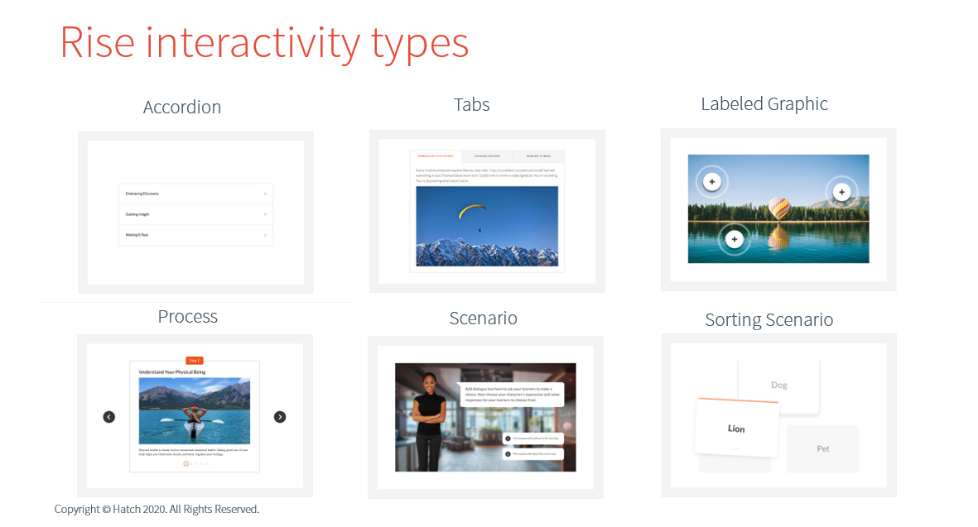

Writing guidelines
- See Brand guidelines, specifically, “do’s and don’ts guidelines”, for questions regarding document branding. This includes color, font, text size, and other guidelines.
  - Logo:
    - Preferred to be Hatch orange on a white background
    - No smaller than 54 pixels in width
    - Leave protected white space around the logo (same as the height of the “H”).
  - Colors: (see brand guidelines “Color Palette” for more information):
    - Hatch orange: #E84A37
    - White: #FFFFFF
    - Hatch blue grey: #425563
    - Hatch safety yellow: #E1E000
    - Dark grey: #53565A
    - Light grey: #888B8D
    - Generous use of white space is suggested. Use of Hatch yellow should be limited (as an accent/contrast)
  - Avoid incorrectly using the logo or any graphics by distorting their size, using special effects, changing colors, or making rotations.
  - Font:
    - Source Sans Pro is preferred (all weights may be used)
      - If not available, use Arial
- See Style Guide for information on how to maintain consistency in written content.
  - Preferred 3rd person impersonal voice at about a grade 7 reading level
  - Contractions (don’t, can’t, etc.) are permitted.
  - For listed items in a paragraph, always use a comma before “and” for clarity.
  - Spelling is American English (except for regional communications).
  - Hatch is considered a singular entity for terms of pronouns/possessives (we, us, our).
  - See “Style Preferences (Section 6.3) for style and spelling preferences for common Hatch terms.
  - Speak to the learner directly, use words like “you.”
  - Write in simple declarative sentences in the nominative function (subject-verb) and avoid passive voice (ex. “The plane was flow by the pilot.”).
  - Limit sentence length, using conjunctions to join clauses within a sentence only once.
  - “Hatchify” the language where possible, for example “being unconditionally honest”.
  - Avoid colloquial phrases/figurative language as they are difficult to translate.
- Hatch uses Chicago style for formatting:
- Titles are sentence case, in quotation marks (not bold),
- Title case is used only for the name of an offering, team, or someone’s title (ex. “Mining and Mineral Processing,” “Mining and Mineral Processing Group,” and “Managing Director”.).
- A lead sentence is required before bulleted lists. The lead sentence should finish with a colon.
- Capitalize the first letter of each bulleted item, and bulleted items with full phrases/sentences should end with a period.
- Bulleted lists with items only should have a period on the last bullet item.
- The abbreviations i.e. (“that is”) and e.g. (“for example”) should be confined to parentheses or notes and should be followed by commas.
- Single digit numbers should be spelled out; numbers 10 and above should be expressed numerically.
- Em dashes are used before and after anecdotal information that interrupts a larger sentence. Do not add spaces before and after em dashes (e.g., “The project—which Hatch has supported since FEL1—is nearing completion.”).
- Commas and other punctuation precede the closing quotation mark when used in direct quotes from individuals (e.g., “The team did a remarkable job,” she said).
- When naming conferences, events, and other titles within quotation marks, commas and other punctuation will be placed outside the closing quotation mark (e.g., This year’s theme, “Revolutionizing safety: A journey of innovation”, featured…).
- When referring to a project, project is lower case (e.g. Kenmare Moma Mining project)
- When referring to a title of a role, all words are upper case (e.g. Engagement Manager)
- When referring to a function, all words are lower case (e.g. engagement delivery coordinator)
- All titles, menu titles and headers are to be written in sentence case
- Course and job aid titles are to be written in sentence with no additional special characters (e.g. AssetXD Access job aid)
- Changes to the storyline must be reflected in the storyboard
- Items referred to that are capitalized within the AssetXD environment will also be capitalized in our text (e.g. Saved Views)
- General bullet points do not have periods unless they are written in full sentences
- First instance of acronym: spell out full word and include acronym in brackets. Ongoing in file can continue to use acronym e.g., Manifesto Driven Leader (MDL).
- Reference to any project/model in AssetXD will be in bold

Hatch terminology and acronyms
- IDP Glossary .xlsx
Hatch Term | Acronym (if applicable) | Description
eLearning course |  | Online, self-paced training
Online/digital course |  | Online, self-paced training
Learning |  | Training
Live session |  | Instructor led training
Manifesto |  | Hatch Manifesto, our values
Colleague |  | Fellow employees
Team member |  | Fellow employees working within the same team
Client |  | Customers of Hatch
Partnering with the client |  | Working with the client
Africa, India, Middle East | AIM | One of the global Hatch regions
Australasia | AUA | One of the global Hatch regions
Eastern Canada | ECA | One of the global Hatch regions
Europe | EUR | One of the global Hatch regions
South America | SAM | One of the global Hatch regions
United States of America | USA | One of the global Hatch regions
Western Canada | WCA | One of the global Hatch regions
Digital Project Delivery | DPD | How we deliver our projects
ShareCenter |  | The primary suite of tools used to delivery our project documentation
AssetXD
AssetXG
AssetXR
AssetXS
ControlShare
DocShare
DataShare
Engagement Estimate
FormShare
InfoShare
PackageShare
ReportShare
Delivery Knowledge Portal (DKP) | DKP
Super users
Users
Instructional Designer | ID
Project Manager | PM
Engagement Manager | EM
Project Information Manager | PIM
Project Automation Technology | PAT
engineering design coordinator | EDC
Minimum Digital Standards | MDS
Common Data Environment | CDE
Advanced Work Package | AWP
Construction Work Package | CWP
Engineering Work Package | EWP
 | OWP
Brownfield |  | Site where there are existing operating facilities or structures within the confines of the project work
Third |  | Do not use the number with rd (3rd) when describing third parties

Visual approach
- See Brand guidelines, specifically, “Our visual identity”. All choices made must align with these guidelines.
- For AssetXD courses throughout the curriculum, we would like to utilize the same look and feel:
  - Dark Hatch blue/grey backgrounds with white text.
  - Imagery complementing this color pallet and leaning into the blues.
  - Futuristic/clean lines feel.
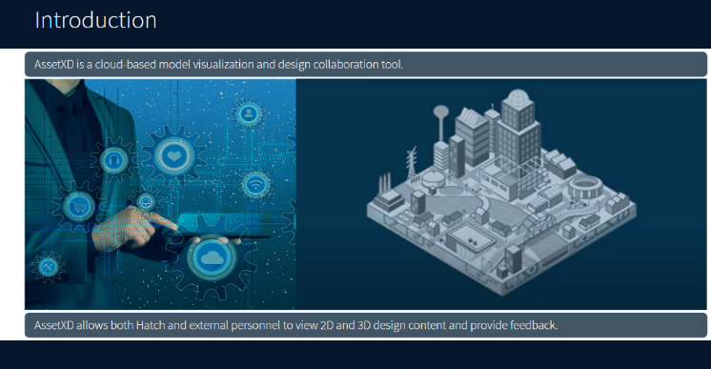
  - Examples:


Imagery
See Brand guidelines, specifically, “Imagery.” In general we want images that emphasize the large scale of our projects and thinking that emphasize warm light and have a dynamic composition. Our preferred images often have unique angles or cropping. We prefer images representing Hatch colleagues in their typical working environment with candid styles (not posed/looking into the camera). For most employees the typical working environment involves client sites, but we also have employees working in an office environment. Images should not look overly formal and ‘corporate’ – minimize suit wearing, skyscrapers or fancy looking offices, etc.

Considerations
- Any images representing Hatch colleagues on site must be wearing Hatch-approved personal protective equipment (PPE). These images should be taken from the Hatch-approved imagery to ensure they follow our guidelines.
  - Hatch PPE includes
    - hard hat
    - long sleeve shirts
    - eye protection (not glasses, real PPE eyewear)
    - ear protection
    - gloves
    - name patch
    - work boots
    - work pants
    - coveralls
    - jacket
    - Note: Within Media Hub, images that contain PPE and have been approved by the Hatch Health and Safety are tagged with “PPE”.
- Diversity and inclusion must be considered for any on-screen representation of people. Please provide a mix of genders, races, ages, etc.
- Consider colors for accessibility (i.e. colors that are difficult to read, certain colors on top of certain background colors, etc.)
- Also consider Hatch’s partnership with Bentley to ensure that all images, links, etc. are approved for use.
- When creating assets for the course (e.g. storyboard or other design document), label all images that appear in a section with a descriptive title
  - Use this label to reference the image in the storyboard or design document
- Ensure you define where all referenced images are stored
  - All images are to be stored in an associated course image folder (titled to match the corresponding label within the storyboard/design document).
- Maintain a master image spreadsheet for reach course (see template HERE) indicating the image title, caption, alt text, source, and current location.
  - Update the spreadsheet for your course when you add any new images to the course or change existing images

Evaluation strategy
- Level 1: Help identify satisfaction and felt level of support (i.e. Default Hatch Program survey)
- Level 2: Knowledge of effective Hatch methods, aligned with the Manifesto (i.e. scenario-based knowledge checks, simulation, and VILT activities, certificate of completion awarded at Regional Town Halls)
- Level 3: Behavioral change (self-reported/others-reported) (i.e. increase in projects using AssetXD, increase in certified Engineers and Designers trained on Asset XD, increased participation in members of CoP’s, completion of simulations deployed post learning)
- Level 4: Business metrics (Earlier detection of project issues, reduced reputational damage due to clash management, reduced project brownfield design issues)
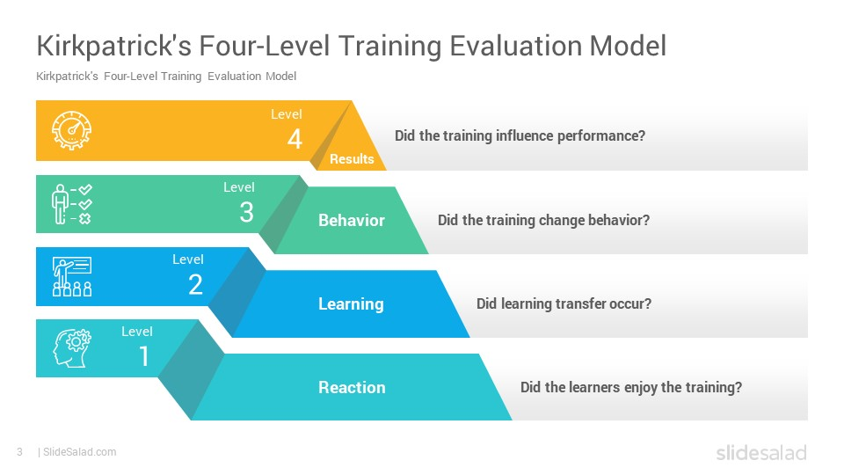

Knowledge checks
These knowledge checks (KCs) are meant to be realistic and relevant scenario-based knowledge checks that enable employees to apply their knowledge and skills to Hatch-specific practice situations, in a safe space before applying on the job. KCs should help participants retain knowledge and skills while also increasing motivation and self-efficacy. Knowledge checks should have a direct link to each course’s stated learning objectives. Referring to Bloom’s Taxonomy, KCs may focus on different levels based on the learning objective. Where it makes sense, we would prefer knowledge checks to measure the higher levels of Bloom’s taxonomy (like apply and analyze) as much as possible The format of KCs can be: multiple choice, T/F, etc. as per Articulate Rise tool. The specifications for Knowledge Checks are as follows:
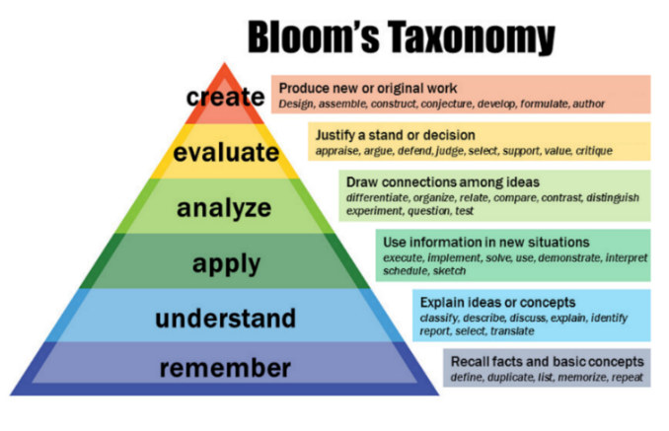
- Point of view: The scenario in the knowledge check is to be written in a second-person perspective to enable participants to view themselves in the scenario. (e.g. Imagine this – You are moving homes this month…). If using a simulation, the simulation should be set around a realistic task that a learner would need to accomplish using an interface that replicates the look of the actual Asset XD interface or the actual interface itself.
- Length: Scenarios and simulations are to be ‘to-the-point” including only the most critical pieces of information to set context and communicate key information linked directly to the learning objectives.
- Level of difficulty: medium difficulty level; the answers should not be easily identifiable and require participants to reflect on and apply what they have learned so far in the Hatch context. Refer to “understand” and “apply” levels from Bloom’s Taxonomy.
- Scoring: KCs are used as a practice activity and scores are not meant to be displayed, but feedback is to be shown to reinforce the correct behavior
- Feedback per question: depending on if the answer is correct or incorrect, feedback of best behaviors should be shared. Feedback should reinforce correct answers and inform participants of why their answer is incorrect (i.e. more than “correct” or “incorrect”)
- Response options: Options must be of the same or similar length (i.e., character count). It is suggested to limit the “select all that apply” style of question writing, and instead ask for one correct response.
  - Note: Please ensure correct and incorrect responses are similar in length. If not, length may be an indicator of which response is correct.
  - Note: See Knowledge Check resources for examples of realistic/relevant scenario driven knowledge checks.

Additional LMS micro-learning requirements

Completion requirements and progression
- Participants’ progress through the online course should be visible, identifying what has and has not been completed
- Completion requirements are to be clear and visible; unable to be skipped (i.e., if an interaction must be completed, it must be clear that it must be completed)
    - I.e. Interactions that are required for progression are to be obvious and easily accessible
    - I.e. Please include instructions or direction for how to interact with interaction to enable user-friendly progression through online course
- Progressing to the next section should not be possible until the current section is fully reviewed
- Upon completion of the course, participants should be able to return to any section they wish and review their knowledge checks without changing their recorded answers
- Bookmarking should be enabled - progress should be saved between sections so that if participants exit the course or has the course timeout, they can return to the micro-learning later and continue where they left off, either while in the same browser window or another
- Any documents linked for resource or reference should be in PDF format when possible. If you receive a document not in PDF format, ask if one exists or if one can be made (when PDF format makes sense).

Videos

Technical specifications
- Ensure all video is 1280 X 720p in resolution.
- Limit the duration of any single video to no more than 9 minutes.
- For content published from Articulate Storyline 360, a video setting of “Adaptive” should be used in the publishing settings.
- MP4 is the suggested file type given its degree of universal compatibility and balance in video quality-to-file size compromise. But confirm this file type with local technology teams.

Reporting requirements
- Publish to SCORM 1.2 with closed captioning for accessibility (if applicable)
- Break up content into separate courses/modules such that no single SCORM .zip file exceeds 500 MB

Demonstration/simulations/practices
Demonstration videos are meant to teach concepts and skills that may benefit from added visual support where text alone may become confusing or require too many static support images to show the full breadth of the concept or skill being explained.
- Demonstrations are short videos – 1-3 minute in duration
- Videos are reserved for explaining concepts, skills, or processes that would benefit from a visual component where the use of static images alone to support text may be too lengthy or complex.
- Demonstrations and simulations will be done in uPerform and will be accessible via Hatch learning through an integration that will directly link to the simulation, demo, or practice activity.

Source Sans Pro RegularDemonstration video inclusions
- Style: Should use the AssetXD application and/or actual images from the screens a learner would view.
- Intro: Where applicable, fade from white background with a Hatch logo
  - Open in full screen or new tab if desired
  - Font size: 43
  - Font type: Source Sans Pro (Light)
  - Font Color: grey (RGB 66 85 99)
- Exit: Same as Intro, given options to rewatch
- Outro: Where applicable, use (Brand Wrap_LogoStinger_rendered.mp4)
  - Allow users to navigate across the video
- Limited words: Limit words on screen
- Colors: Fit the look and feel of the program/AssetXD tool (blues, futuristic, clean line, real look of tool)
- Consistency: Ensure that any videos used are used in the same way (for the same purpose) and use the actual look and feel of the AssetXD tool.
  - Captions and note bubbles: background color white, border Hatch red
    - Font type: Source Sans Pro (Light)
    - Font size: 16
    - Font color: black
    - Direct object of action: As shown in AssetXD and Bold
    - Text entry: Text in quotations “” and bold
  - Buttons: Background grey (RGB 66 85 99)
    - Font type: Source Sans Pro (Light)
    - Font size: 21.5
    - Font color: white
    - Font style: bold
- Concepts, skills, and processes over people: The preference is to demonstrate concepts, skills, and processes in videos through images that do not typically need to include people. However, if not possible, is it fine to include characters/people, as long as they are not too animated.

Simulation/demonstration (non-video) inclusions
- Style: Should use the AssetXD application and/or actual images from the screens a learner would view.
- Intro: Suggested that instructions to the simulation/practice or an overview of the simulation/practice be given. Where possible frame the simulation or practice activity around a realistic scenario.
  - Open in full screen or new tab if desired
  - Font size: 43
  - Font type: Source Sans Pro (Light)
  - Font Color: grey (RGB 66 85 99)
- Exit: Same as Intro, given options to retry
- Content: Align simulation/practice activities to the processes shown in course content or in demonstration videos (use the same steps). It is suggested that practice activities are best for practicing key or complex learning outcomes or skills.
  - Practice scenarios: captions for instructions, no feedback layers, exact process and navigation as using AssetXD
  - Simulations: no captions, no feedback layers, exact process and navigation as using AssetXD
- Consistency: Ensure that any videos used are used in the same way (for the same purpose) and use the actual look and feel of the AssetXD tool.
  - Captions and note bubbles: background color white, border Hatch red
    - Font type: Source Sans Pro (Light)
    - Font size: 16
    - Font color: black
    - Direct object of action: As shown in AssetXD and Bold
    - Text entry: Text in quotations “” and bold
  - Buttons: Background grey (RGB 66 85 99)
    - Font type: Source Sans Pro (Light)
    - Font size: 21.5
    - Font color: white
    - Font style: bold

Reporting requirements
- Publish to SCORM 1.2 with closed captioning for accessibility (if applicable)
- Break up content into separate courses/modules such that no single SCORM .zip file exceeds 500 MB

Global course considerations

General approach
Encouraging a flat and connected organization: Hatch is a global organization, with corporate headquarters in the North America (Mississauga, Ontario, Canada). While global and spread across many regions, Hatch is expected have a unified global culture. Given the global nature of this program, the intention is for all participants to be using as much of the same terminology as is possible to allow for discussion of related topics. For example, a user of AssetXD in Brazil should be able to use the tool to achieve the same types of outcomes as a user of Asset XD in Germany. Similarly, the intention is to be able to discuss the AssetXD tool across global teams throughout all sectors.
Thinking globally acting locally: While Hatch is a global organization, it is spread across various regions where each region has cultural differences. To ensure maximum and appropriate adoption of the practices and concepts within this curriculum, it is suggested to keep content clear, concise, and free from cultural/regional nuances.

Appendix

Knowledge check resources
- When possible knowledge checks should be realistic/relevant to participants in their roles. It is suggested that scenario-based or simulation-based knowledge checks be used to ensure that participants demonstrate knowledge/skills in an environment that closely resembles that in which they will be asked to call-upon learned knowledge.
- Some resources/examples of a variety of realistic/relevant scenario-based ways to assess knowledge appear below:
  - E-learning heroes
  - Belvista Studios
  - Scenario Based Interactives with Articulate Rise 360

Hatch is an employee-owned, multidisciplinary professional services firm that delivers a comprehensive array of technical and strategic services, including consulting, information technology, engineering, process development, and project and construction management to the Mining, Metallurgical, Energy, and Infrastructure sectors.
Hatch has served clients for over six decades with corporate roots extending over 100 years and has project experience in more than 150 countries around the world.

Address:
Sheridan Science and Technology Park, 2800 Speakman Drive
Mississauga, Ontario, Canada L5K 2R7
www.hatch.com

